School Name
Mathematics Test 2017
Year 9 |  | Basic Number Skills | Non Calculator
Skills and Knowledge Assessed:  - Carry out the four operations with rational numbers and integers, using efficient mental and written  strategies and appropriate digital technologies (ACMNA183)  - Investigate terminating and recurring decimals (ACMNA184)  - Solve problems involving the use of percentages, including percentage increases and decreases, with and  without digital technologies (ACMNA187) |  |  | Name_________________
Section 1 Short Answer Section
Write all working and answers in the spaces provided on this test paper.

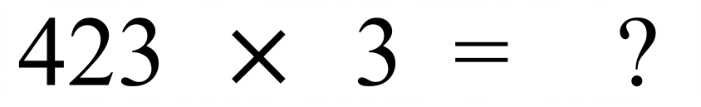

……………………………………………………………………………………………....

……………………………………………………………………………………………….
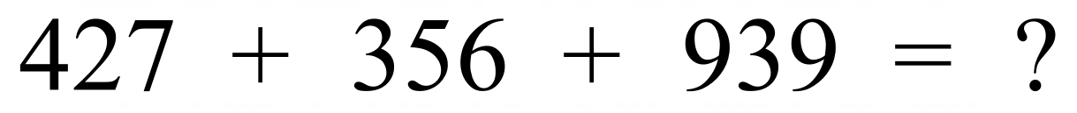

……………………………………………………………………………………………....

……………………………………………………………………………………………….
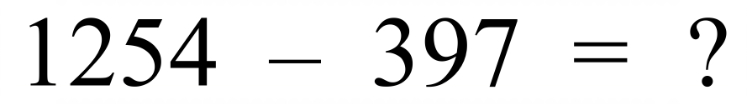

……………………………………………………………………………………………....

……………………………………………………………………………………………….
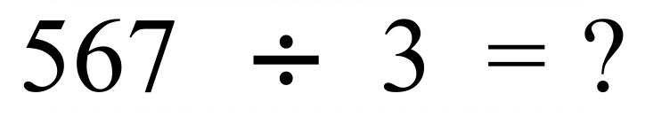
……………………………………………………………………………………………....

……………………………………………………………………………………………….
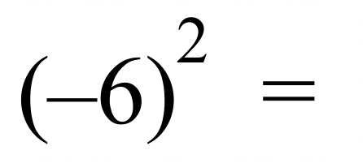

……………………………………………………………………………………………….
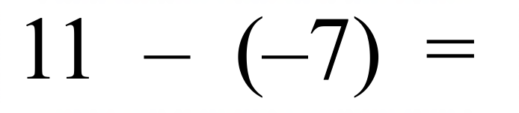

……………………………………………………………………………………………….
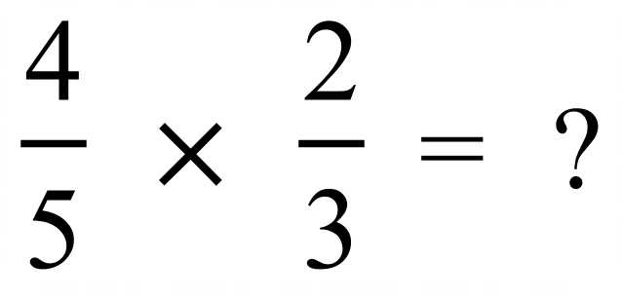

……………………………………………………………………………………………….
What is 40% of 80?

……………………………………………………………………………………………....

……………………………………………………………………………………………….
What is 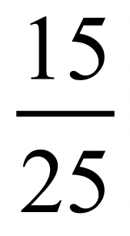 in simplest form?

……………………………………………………………………………………………….
There are 24 animals on a hobby farm. Ten of the animals are sheep.
What fraction of the animals are sheep?

……………………………………………………………………………………………....

……………………………………………………………………………………………….
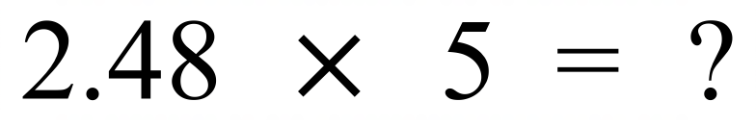

……………………………………………………………………………………………....

……………………………………………………………………………………………….
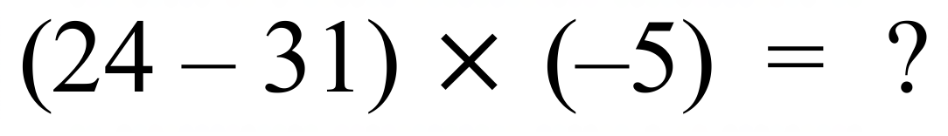
……………………………………………………………………………………………....

……………………………………………………………………………………………….
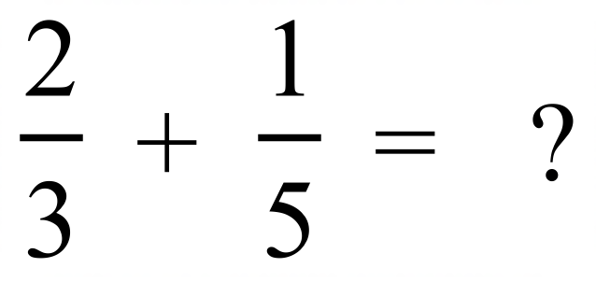

……………………………………………………………………………………………....

……………………………………………………………………………………………….


……………………………………………………………………………………………....

……………………………………………………………………………………………….
What is a score of 25 out of 40 as a percentage?

……………………………………………………………………………………………....

……………………………………………………………………………………………….
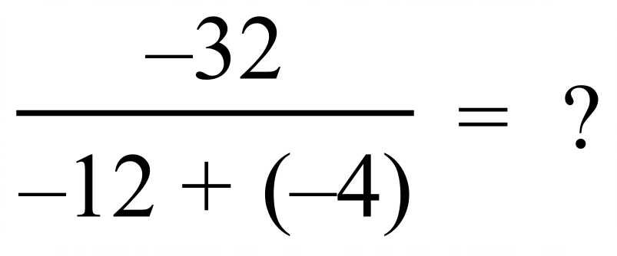

……………………………………………………………………………………………....

……………………………………………………………………………………………….
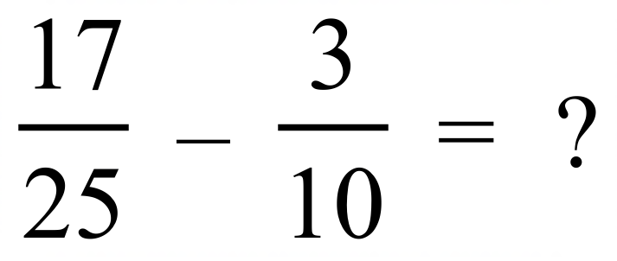

……………………………………………………………………………………………....

……………………………………………………………………………………………….
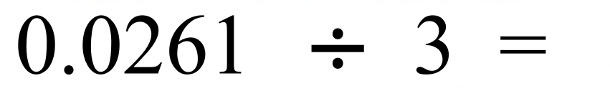

……………………………………………………………………………………………....

……………………………………………………………………………………………….
What is 0.648 when written as a fraction in simplest form?

……………………………………………………………………………………………....

……………………………………………………………………………………………….
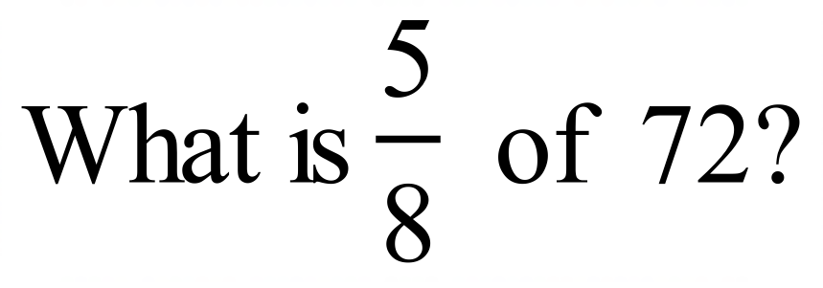
……………………………………………………………………………………………....

……………………………………………………………………………………………….
There are 80 000 people in the audience at concert.
There are 24 000 females in the audience.
What percentage of the audience is male?

……………………………………………………………………………………………....

……………………………………………………………………………………………….
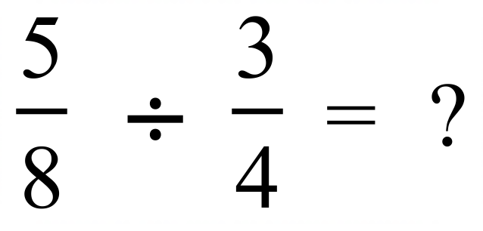

……………………………………………………………………………………………....

……………………………………………………………………………………………….
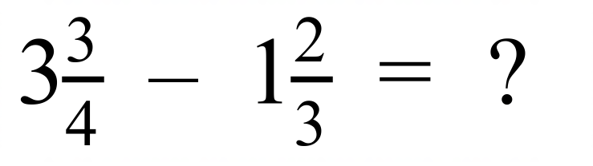

……………………………………………………………………………………………....

……………………………………………………………………………………………….
Decrease one hour and twenty minutes by 5%.

……………………………………………………………………………………………....

……………………………………………………………………………………………….
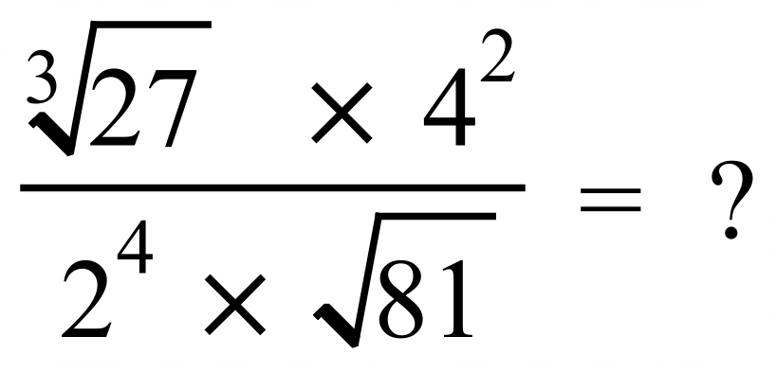
……………………………………………………………………………………………....

……………………………………………………………………………………………….

School Name
Mathematics Test 2017
Year 9 |  | Basic Number Skills | Calculator Allowed
 |  | Basic Number Skills | Name_________________
Section 2 Multiple Choice Section
Mark all your answers on the accompanying multiple choice answer sheet, not on this test paper. You may do any working out on this test paper. Calculators are allowed for this section.

What is the value of the 6 digit in the decimal number 0.0625?
A. ten thousandths B. thousandths C. hundredths D. tenths
Which is the largest?
A. 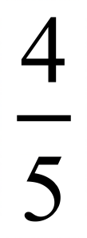 B. 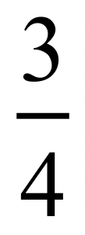 C. 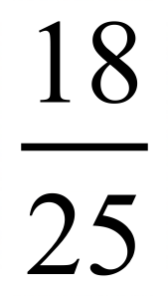 D. 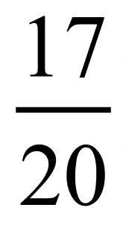
What is 0.36 when written as a fraction in simplest form?
A. 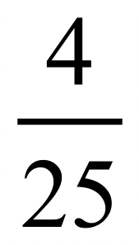 B. 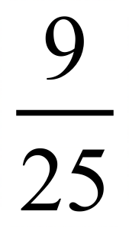 C. 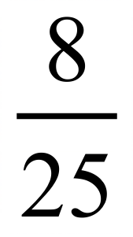 D. 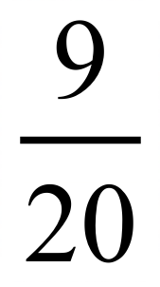
Which fraction is not equivalent to 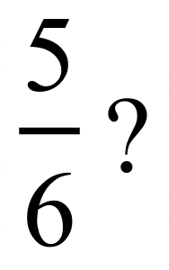
A. 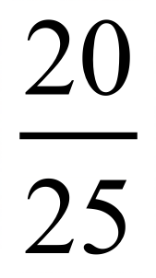 B. 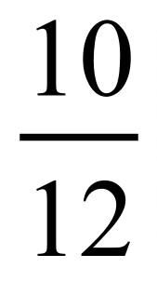 C. 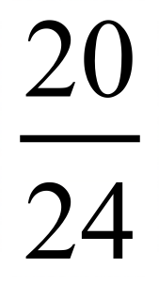 D. 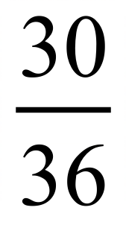
What is 15% of 80 kg?
A. 9 kg B. 10 kg C. 12 kg D. 15 kg
What decimal number is the same as 8%?
A. 0.008 B. 0.08 C. 0.8 D. 8.0
What is 37.5% of 128 ?
A. 48 B. 54 C. 56 D. 64
Write the fraction 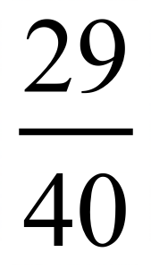 as a percentage.
A. 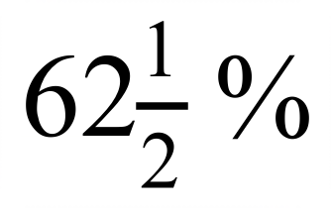 B. 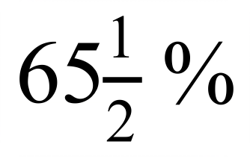 C. 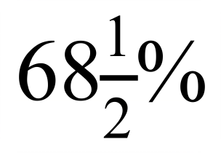 D. 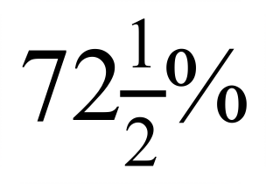
Increase 250 metres by 20%.
A. 270 metres B. 290 metres C. 300 metres D. 350 metres
Evaluate 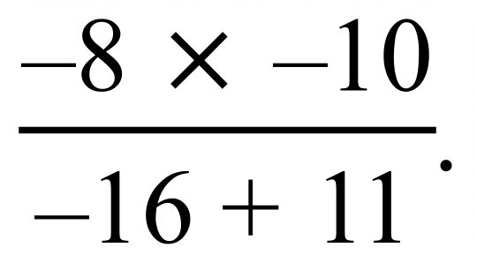
A. 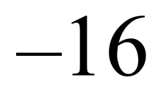 B. 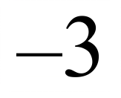 C. 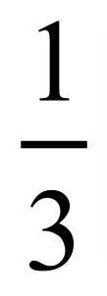 D. 16
Which number indicates the part of the figure which is shaded?
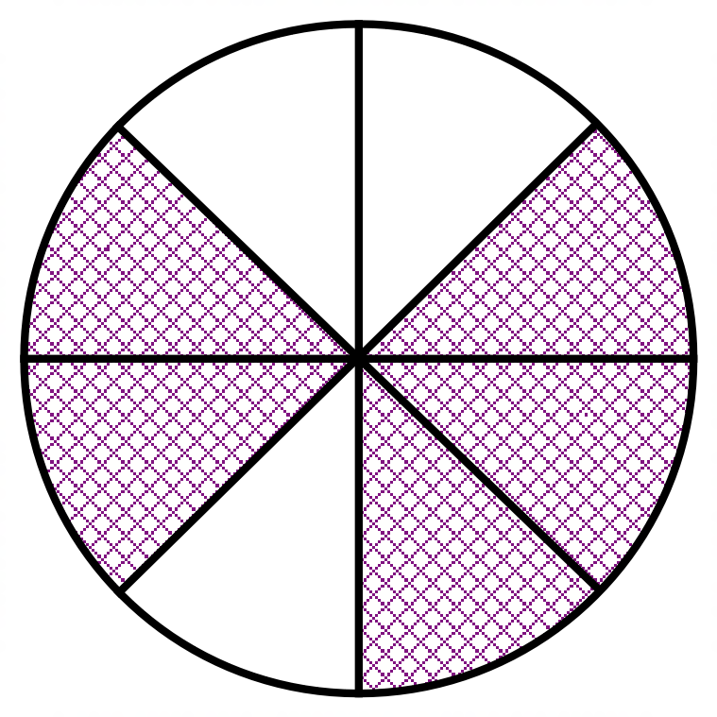
A. 0.6
B. 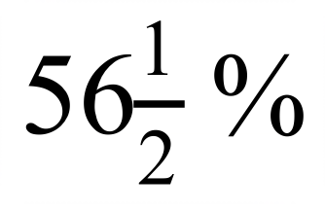
C. 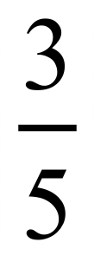
D.
Which set of fractions is in ascending order?
A. 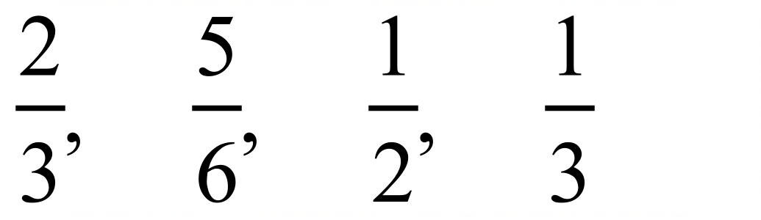 B. 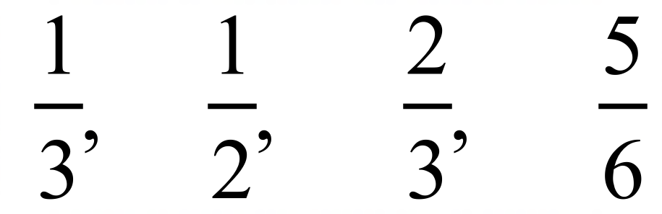
C. 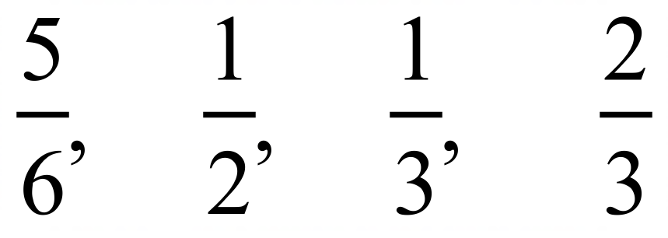 D. 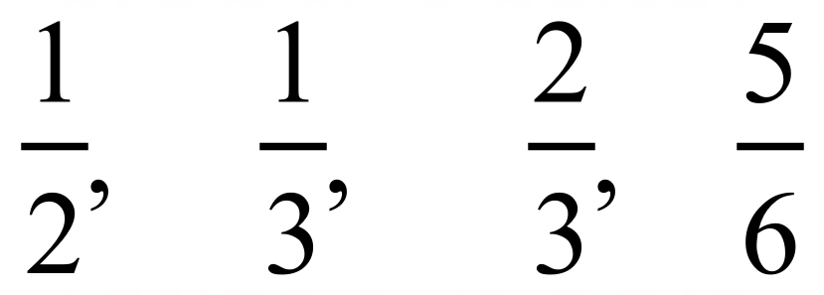
In a card game, Mitchell started with zero points and then scored the points below on the first 5 rounds.
Round | 1 | 2 | 3 | 4 | 5
Points Scored | 100 | –40 | 80 | –200 | –60

What was his score after these rounds?
A. –180 B. –140 C. –120 D. –80
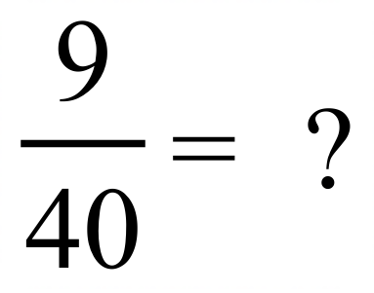

A. 0.225 B. 27.5% C. 0.285 D. 29.5%
A store buys shirts for $30 and sells them $48.
What is the percentage profit on the cost price
A. 54% B. 60% C. 62.5% D. 65%
Which of the points represent the position of 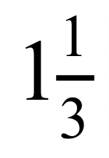 on the number line?

A. Point A B. Point B C. Point C D. Point D
While working during summer, Cody's weight went from 60 kg to 55 kg.
What was the percentage decrease in his weight?

A. 5% B. 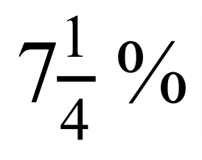 C. 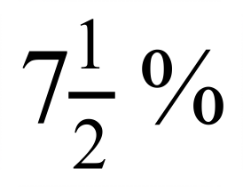 D. 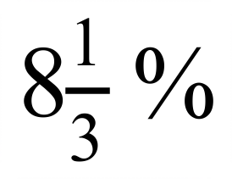
Which statement is NOT true?
A. 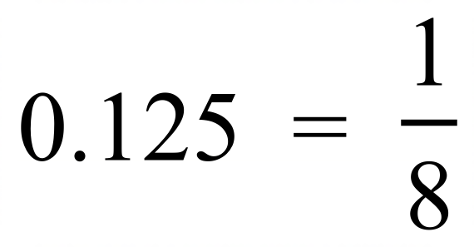 B. 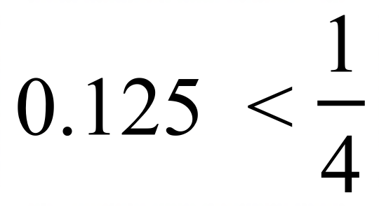 C. 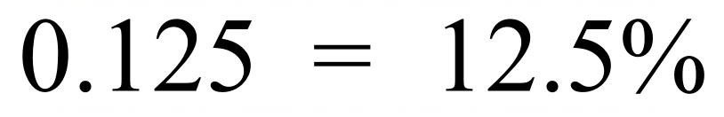 D. 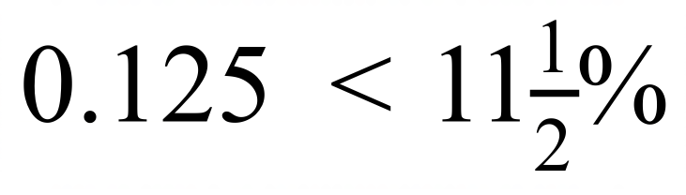
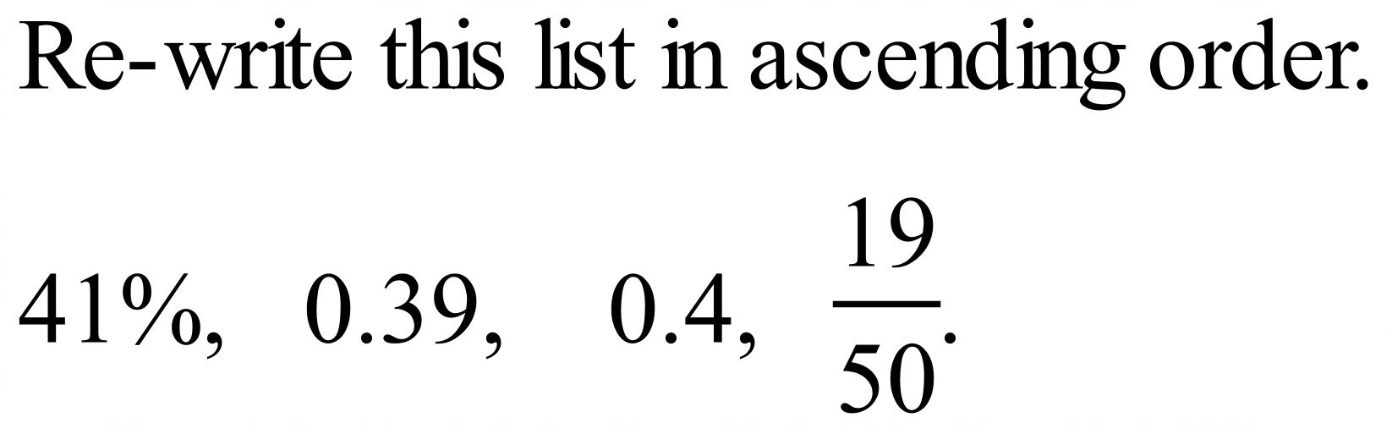
A. 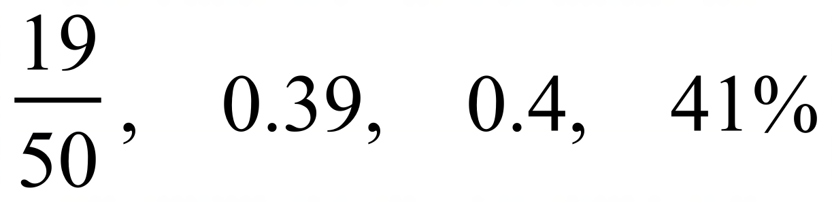 B. 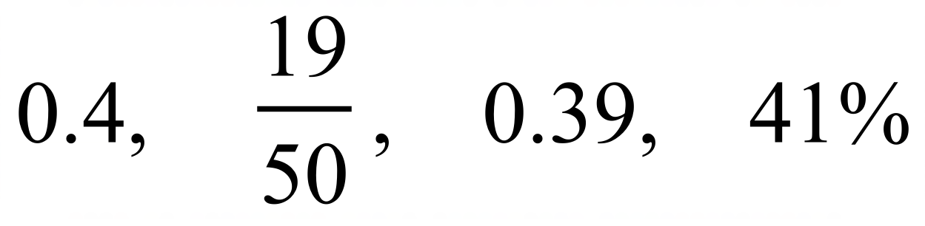
C. 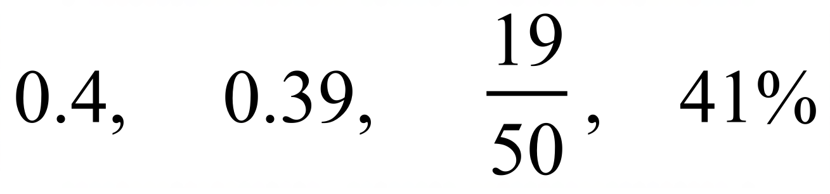 D. 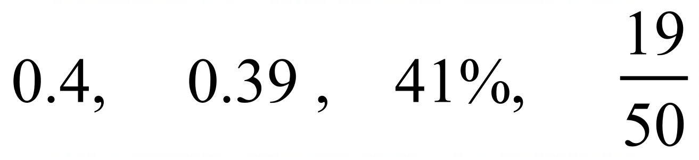

A. 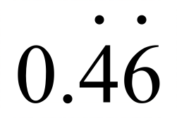 B. 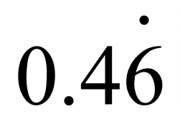 C. 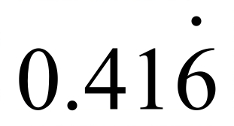 D. 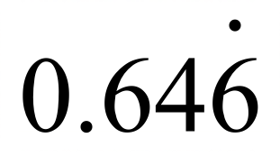
If 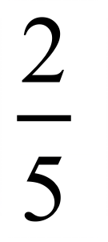 of a group of people is 48 people, what is 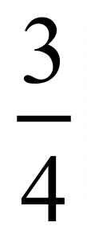 of the same group?

A. 72 people B. 80 people C. 90 people D. 96 people
Which fraction can be written as 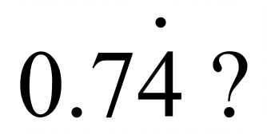
A. 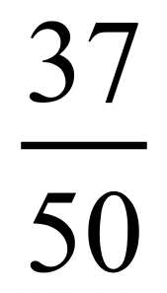 B. 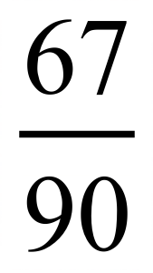 C. 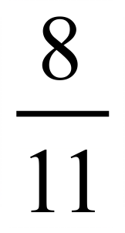 D. 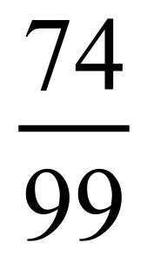
Martha runs a shop and buys a surfboard for $280 and adds a profit margin of 45%.
She then adds 10% GST to obtain the selling price of the surfboard.
What is the selling price?

A. $335.00 B. $434.00 C. $454.20 D. $446.60
Jerry drives a truck which can hold 75.5 cubic metres of topsoil.
The topsoil weighs 0.65 tonnes per cubic metre.
If the truck itself weighs 4.25 tonnes, what is the weight of the loaded truck, correct to 3 significant figures?

A. 51.8 tonnes B. 51.838 tonnes C. 53.3 tonnes D. 53.325 tonnes
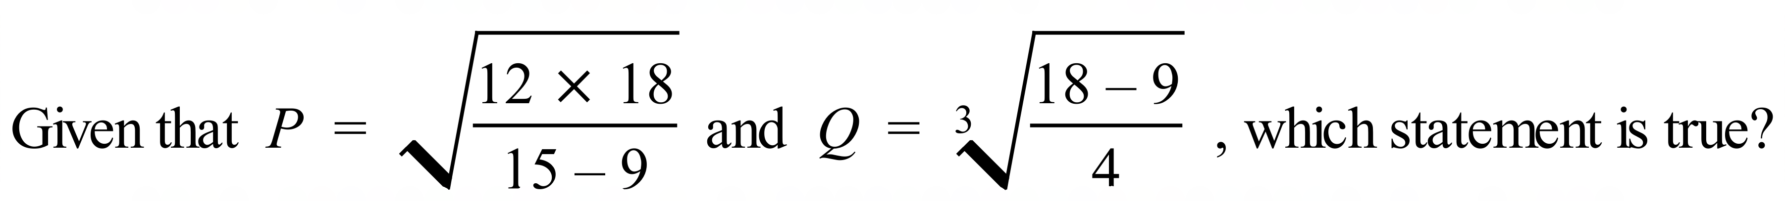
A. P is a rational number and Q is an irrational number.
B. Q is a rational number and P is an irrational number.
C. P and Q are both irrational numbers.
D. P and Q are both rational numbers.

School Name
Mathematics 2017
Multiple Choice Answer Sheet
Basic Number Skills
Name _____________________________________________
Completely fill the response oval representing the most correct answer.
1. A B C D
2. A B C D
3. A B C D
4. A B C D
5. A B C D
6. A B C D
7. A B C D
8. A B C D
9. A B C D
10. A B C D
11. A B C D
12. A B C D
13. A B C D
14. A B C D
15. A B C D
16. A B C D
17. A B C D
18. A B C D
19. A B C D
20. A B C D
21. A B C D
22. A B C D
23. A B C D
24. A B C D
25. A B C D

School Name
Mathematics Test 2017
Year 9 | Basic Number Skills | Non Calculator Section
ANSWERS

Question | Working and Answer
 | 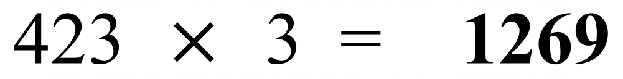
 | 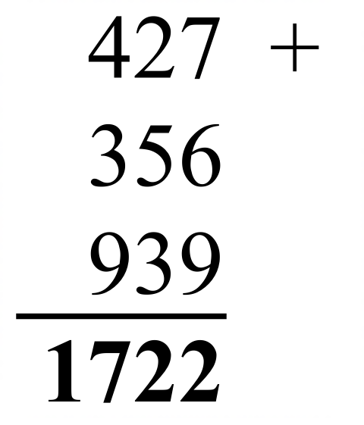
 | 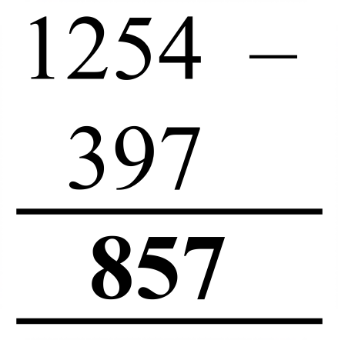
 | 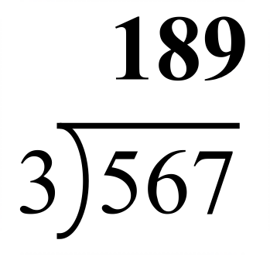
 | 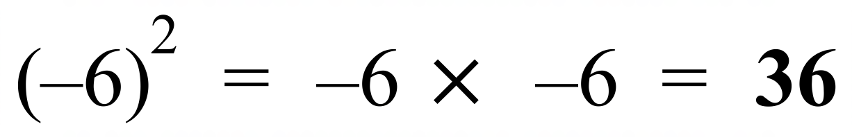
 | 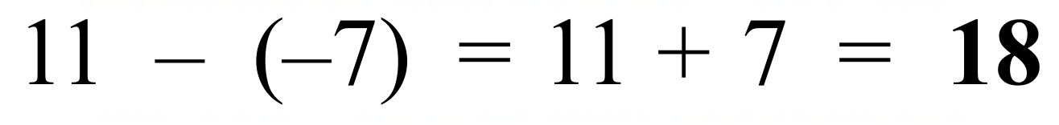
 | 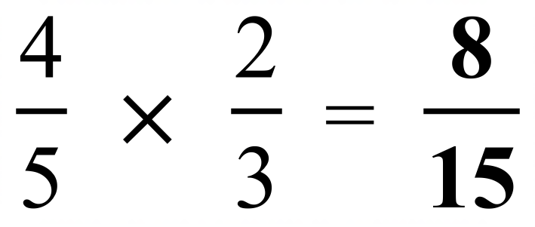
 | 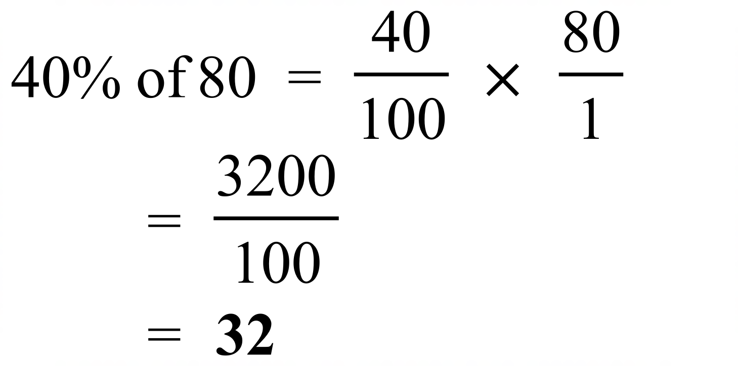
 | 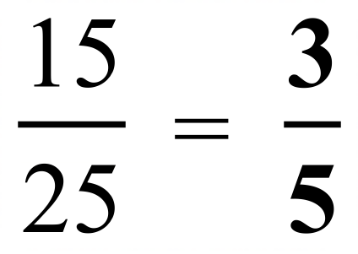
 | 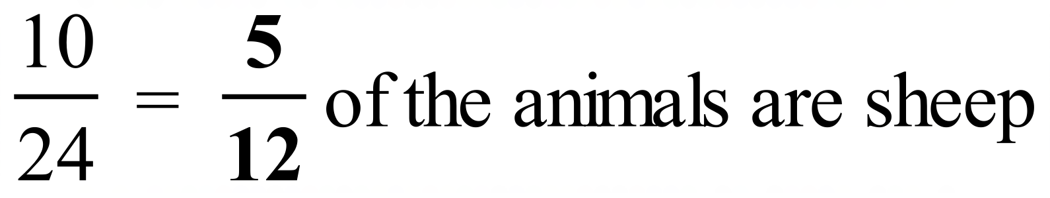
 | 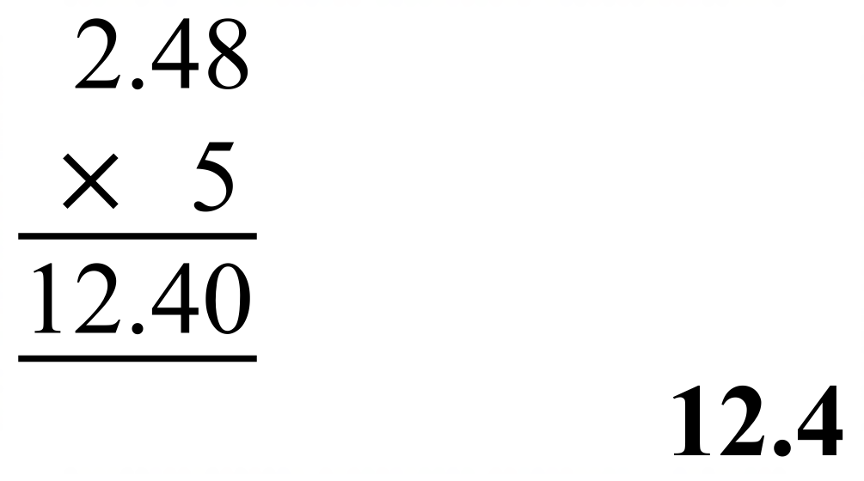
 | 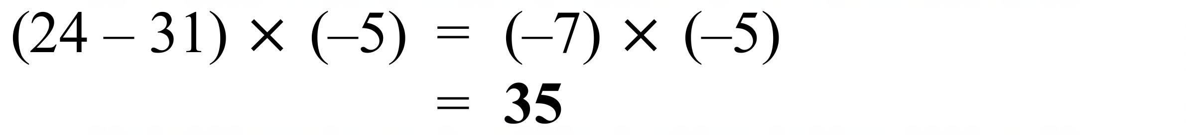
 | 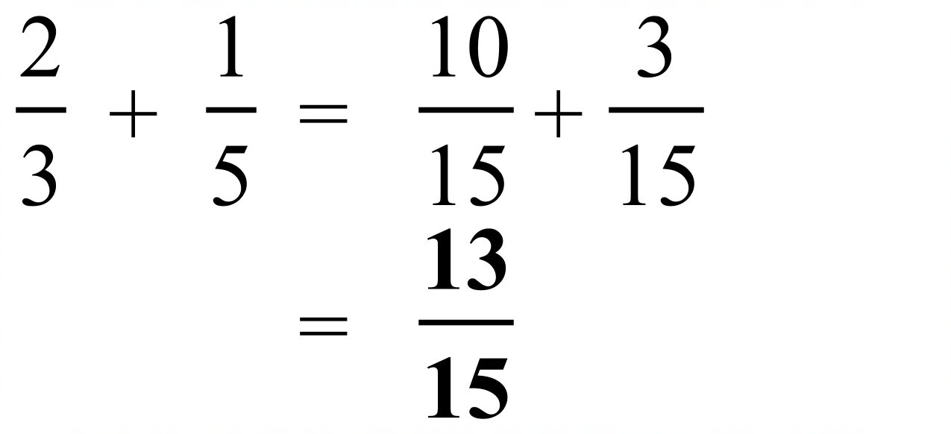
 | 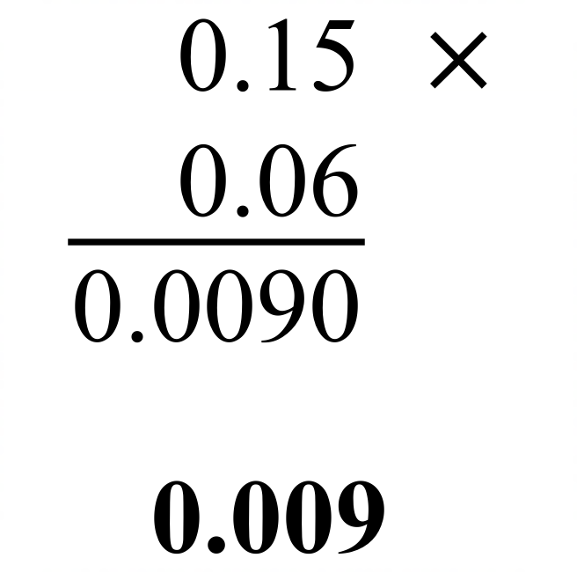
 | 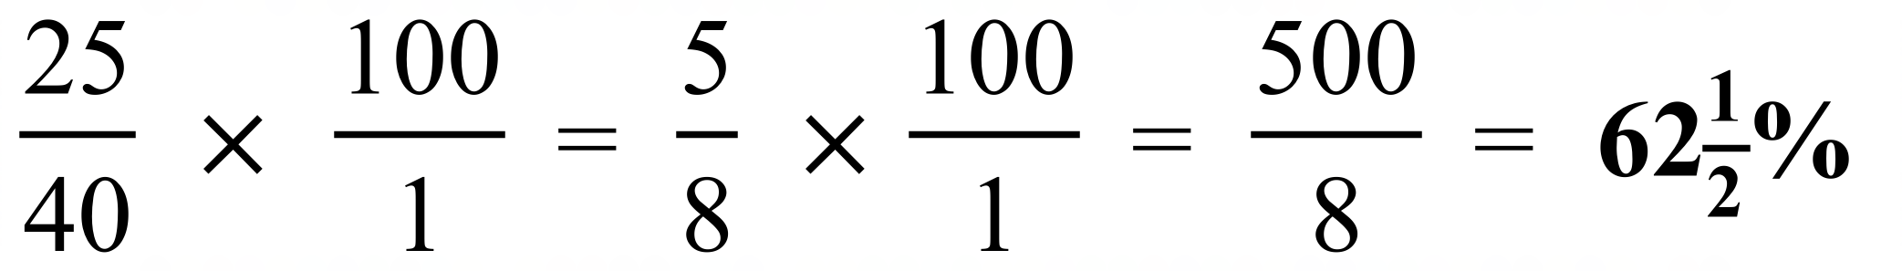
 | 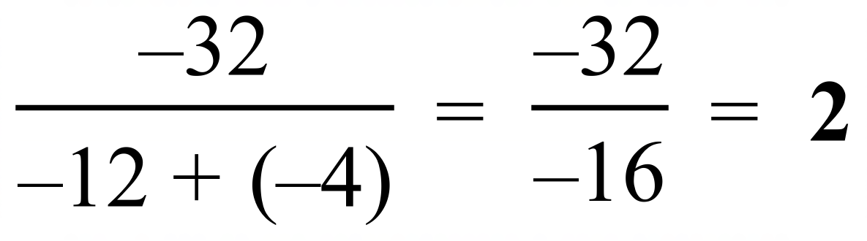
 | 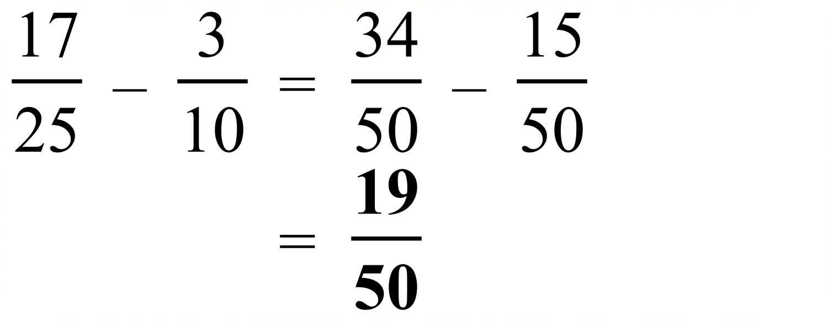
 | 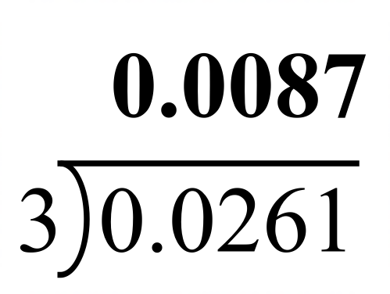
 | 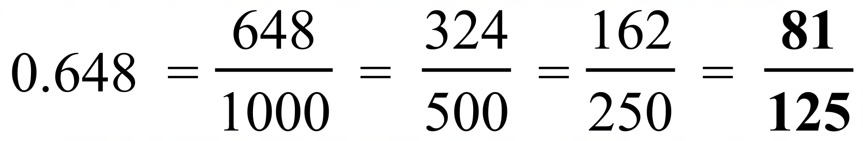
 | 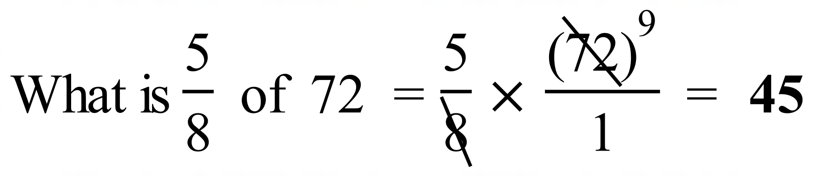
 | 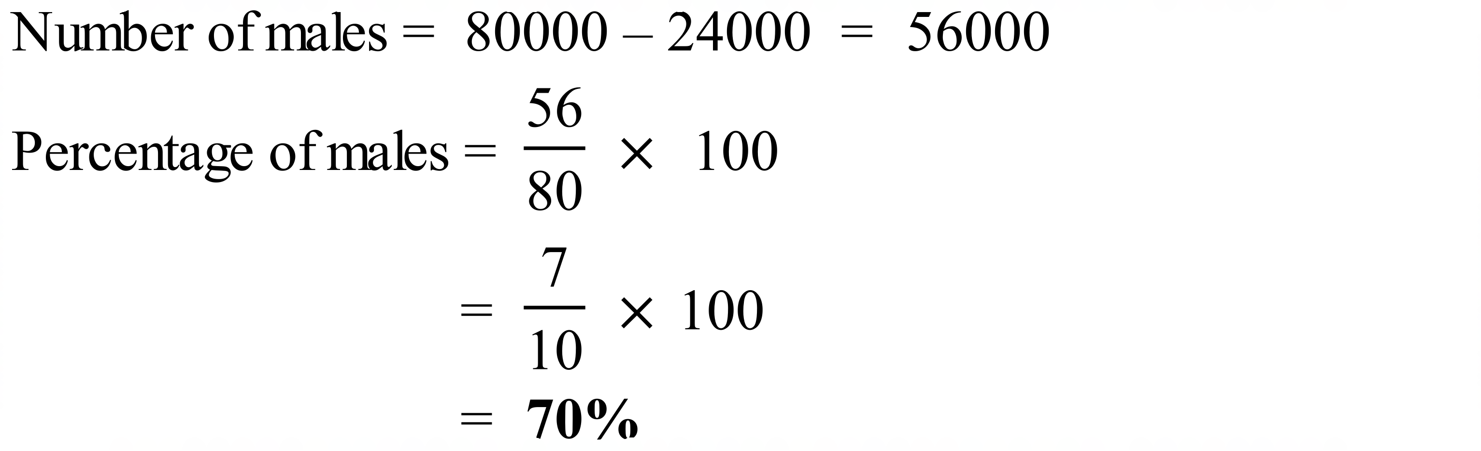
 | 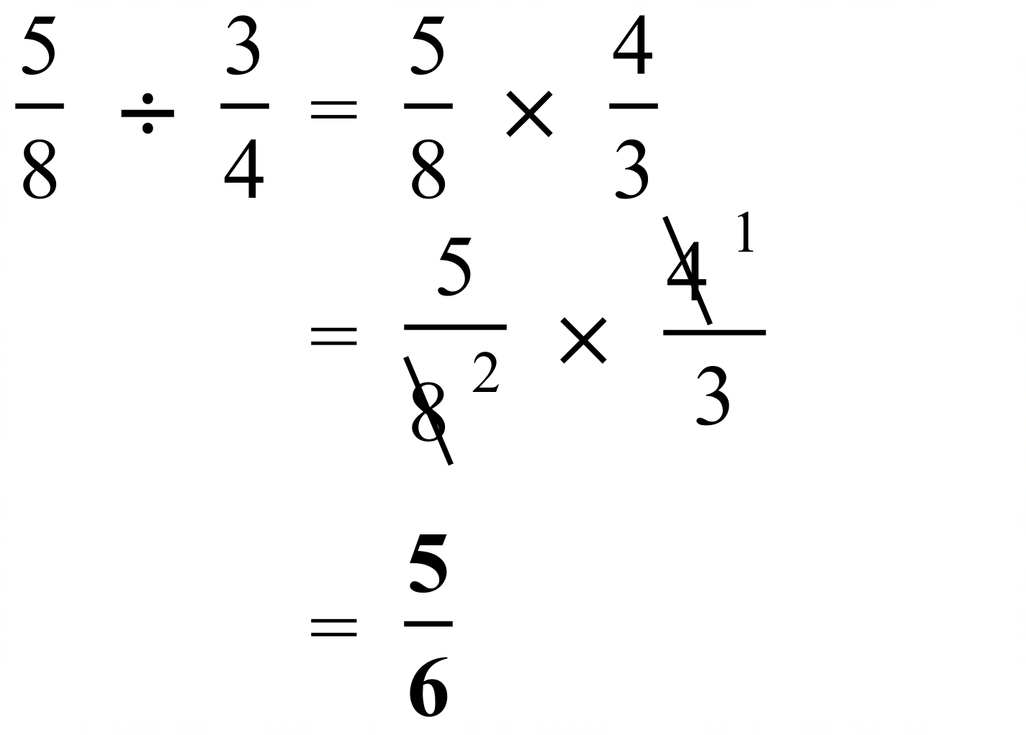
 | 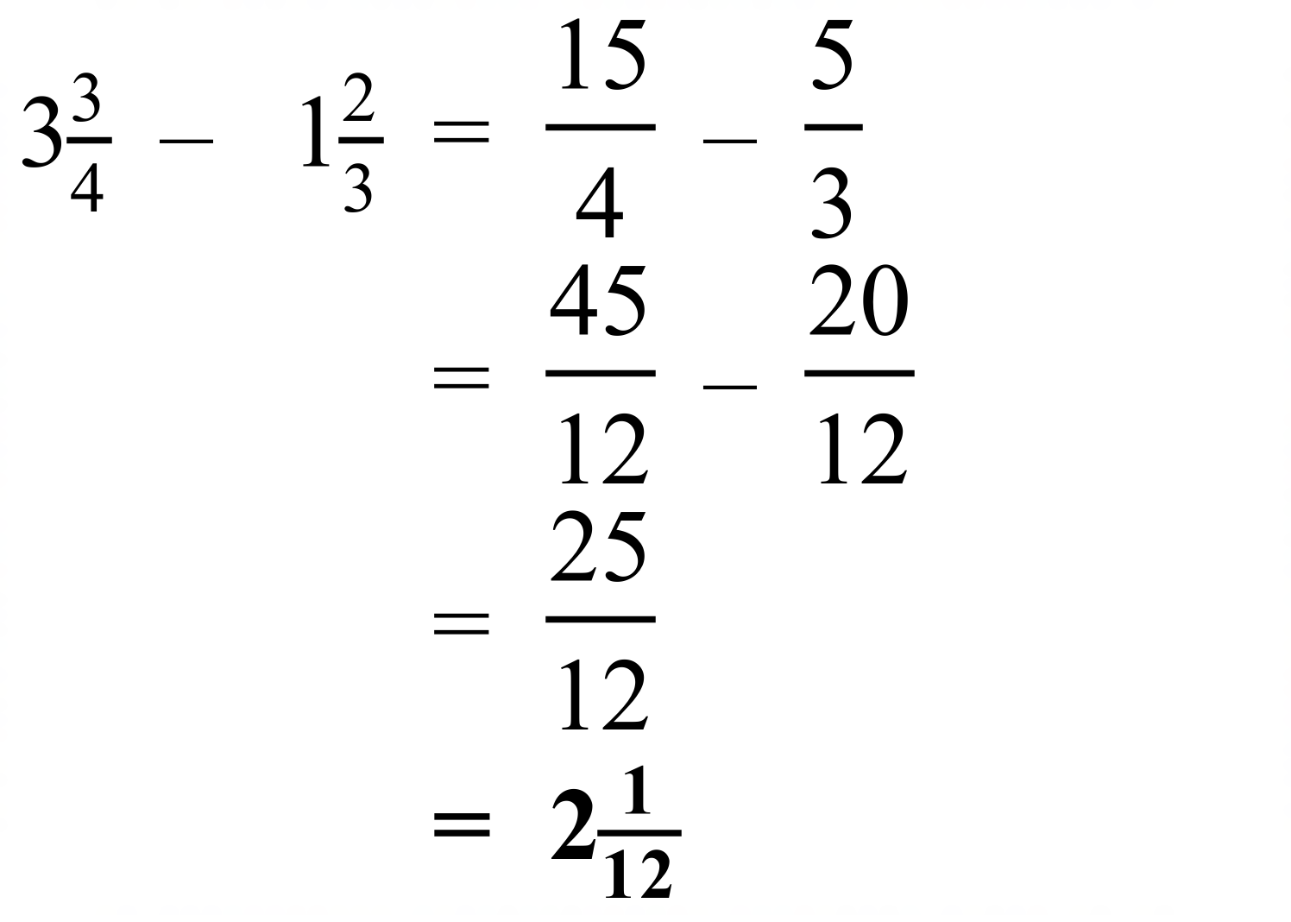
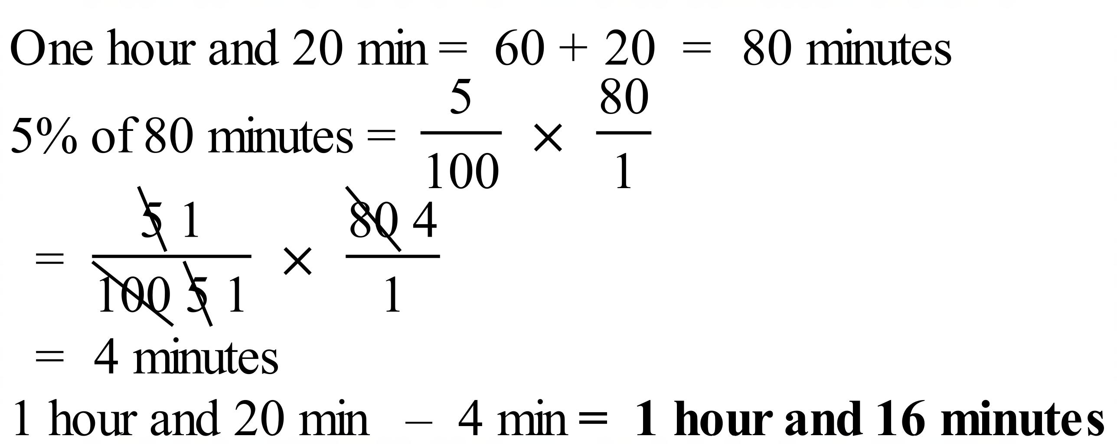
OR
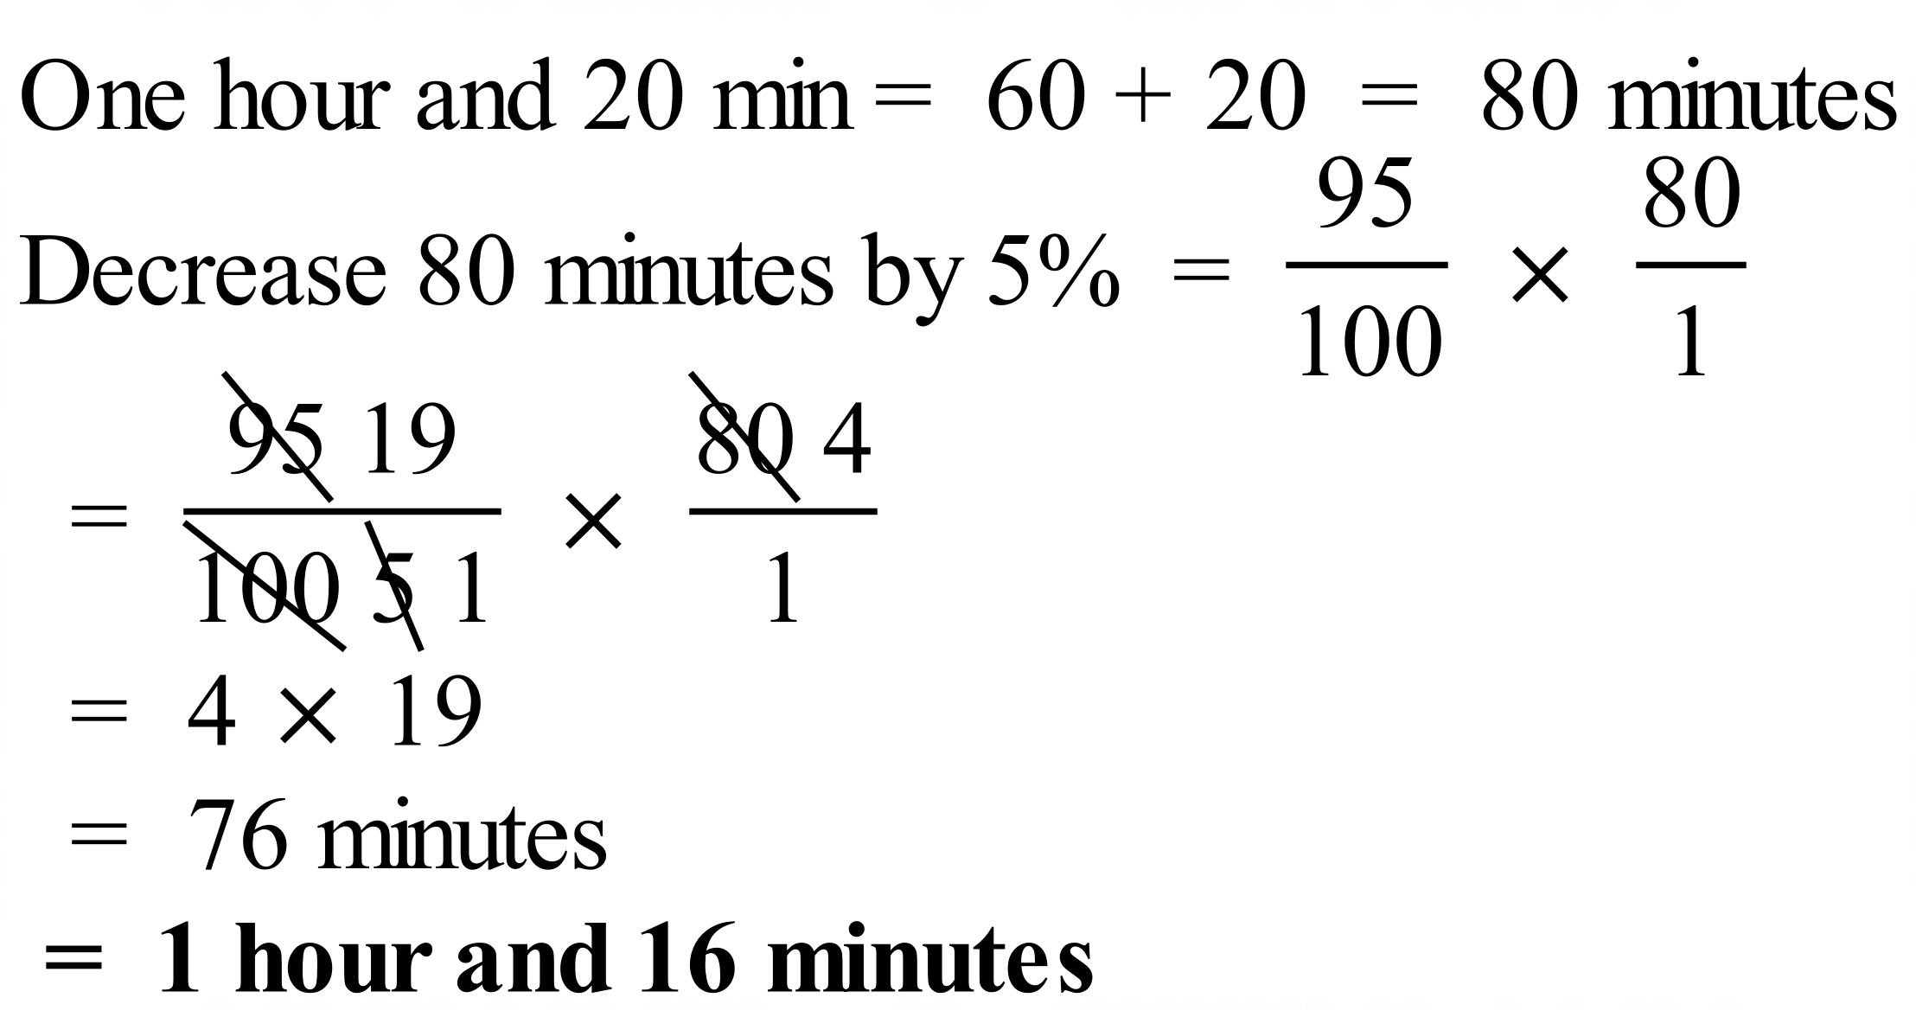
 | 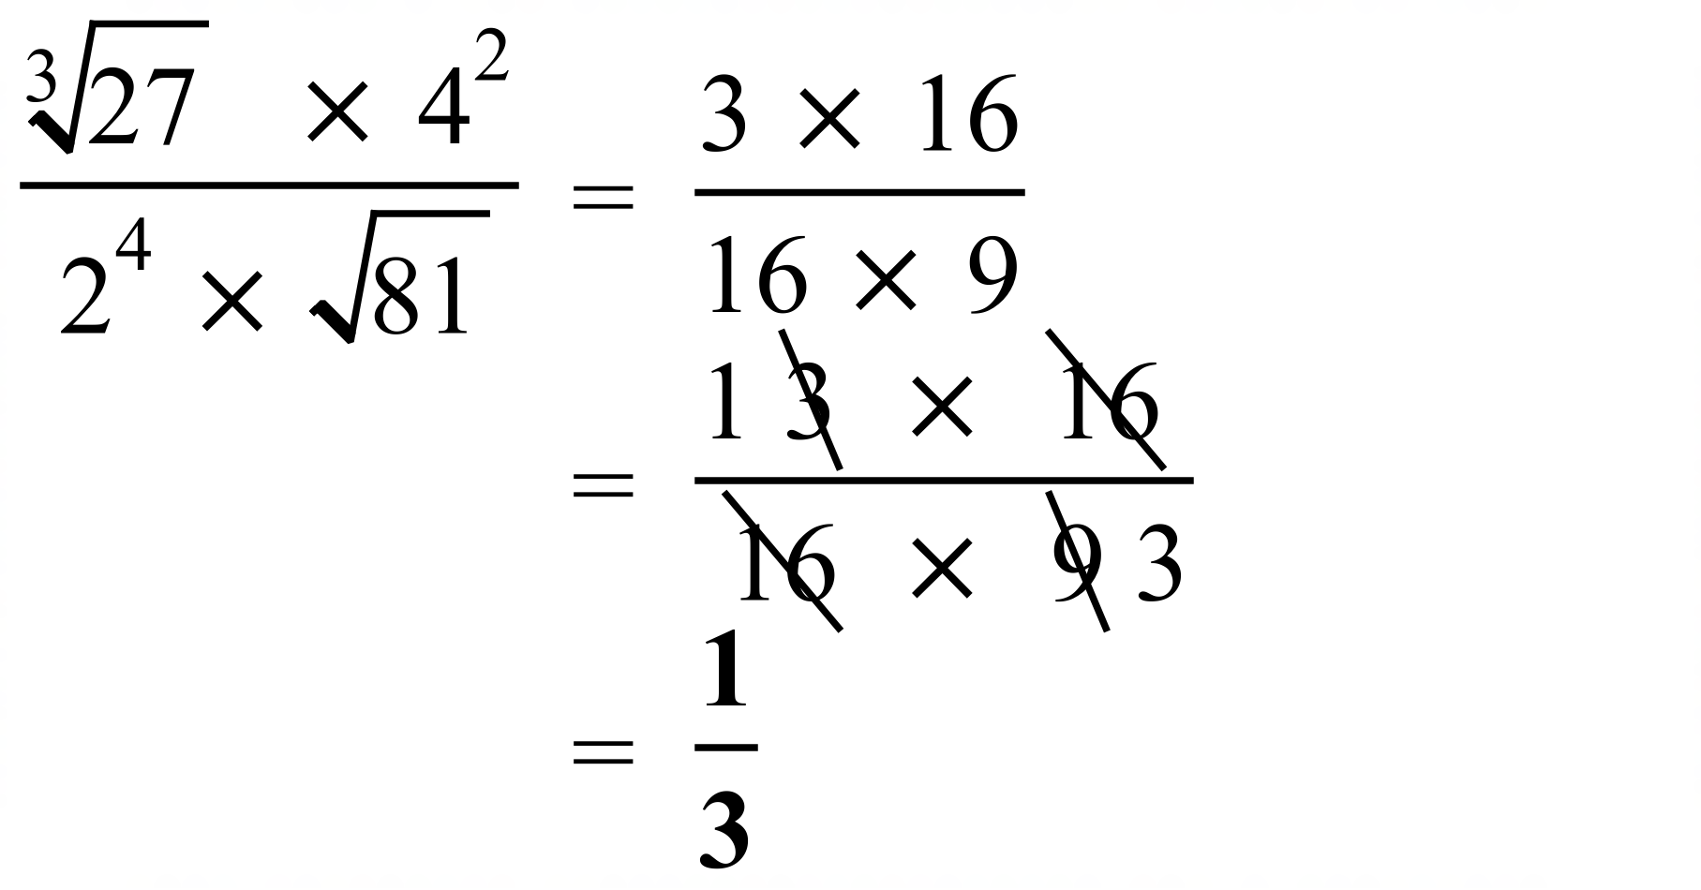

School Name
Mathematics Test 2017
Year 9 | Basic Number Skills | Calculator Allowed  Multiple Choice  Section

ANSWERS

Question | Working | M C Answer
 | The second decimal place is hundredths | C
 | A. 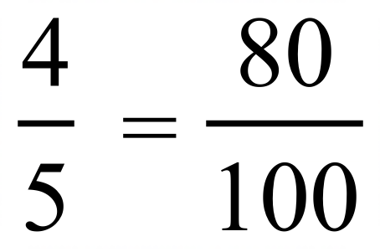 B. 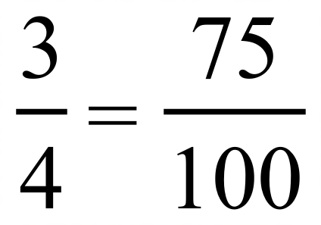 C. 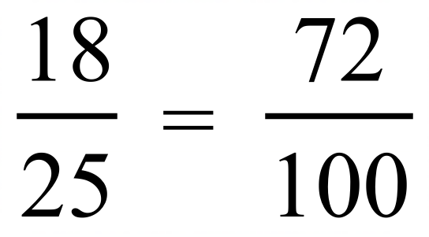 D. 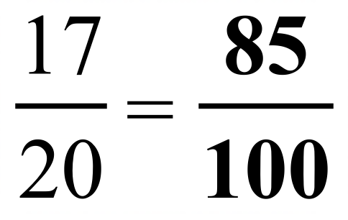 | D
 | 0.36 = 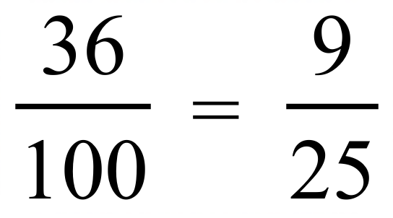 | B
 | 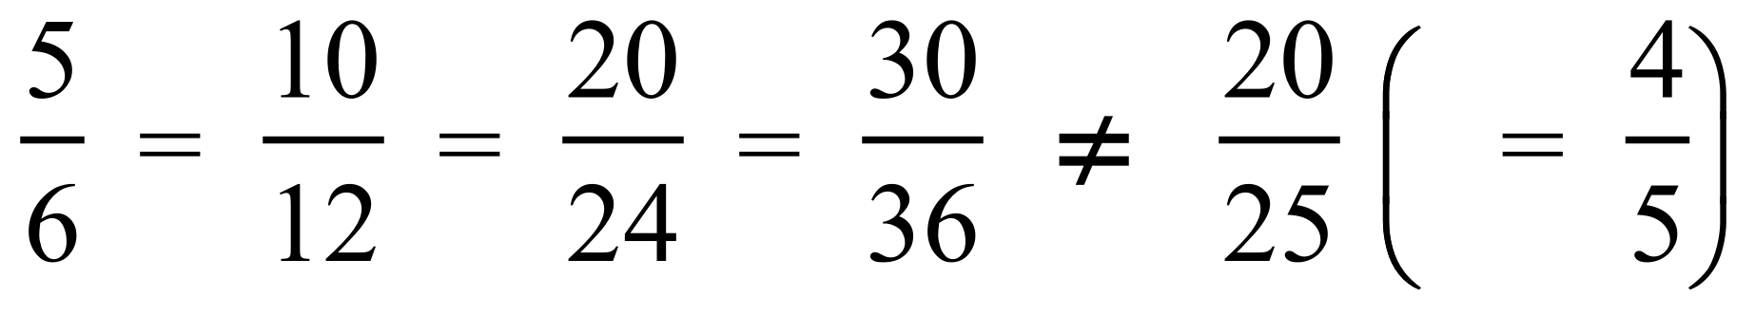 | A
 | 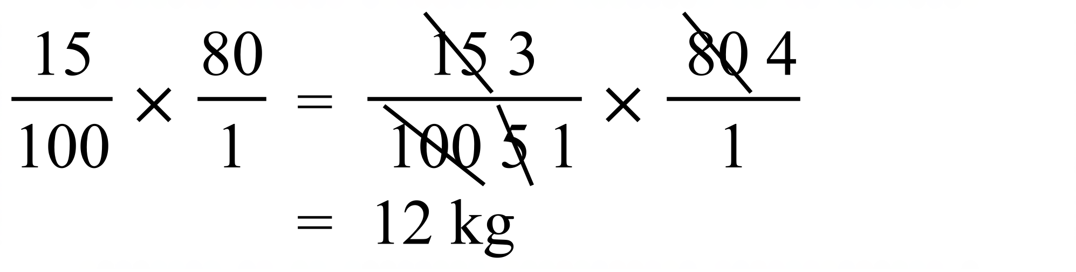 | C
 | 8% = 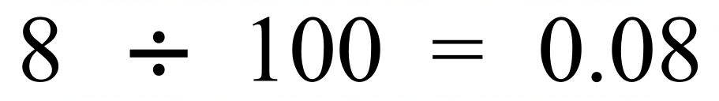 | B
 | 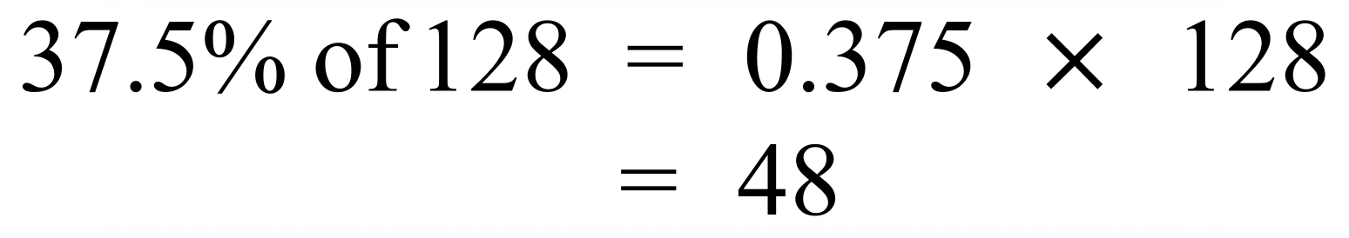 | A
 | 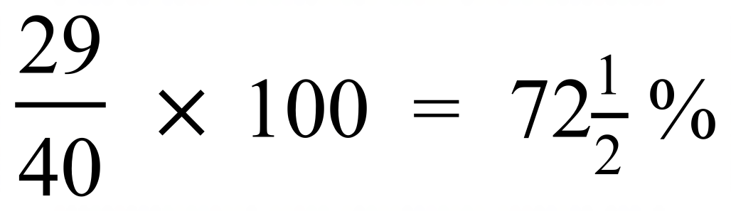 | D
 | 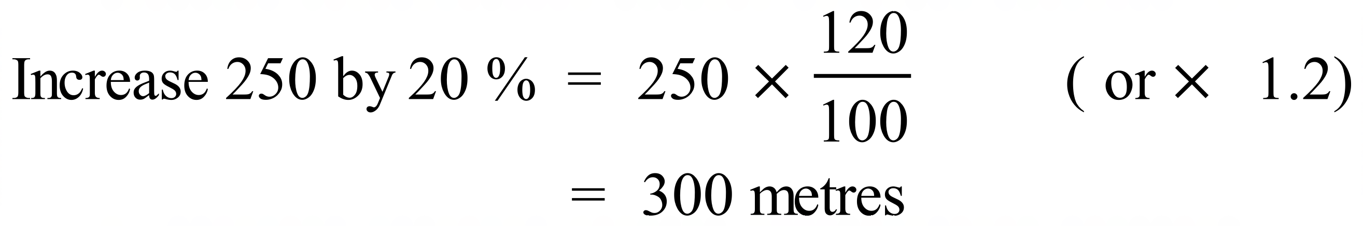 | C
 | 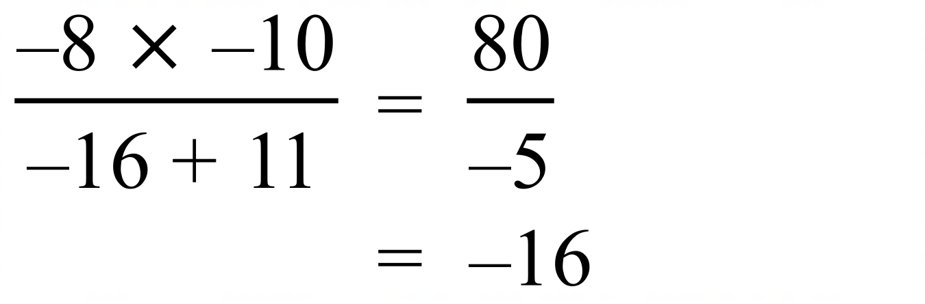 | A
 | 5 parts are shaded out of 8  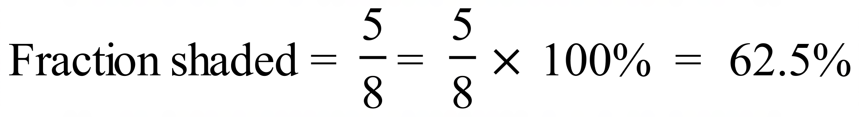 | D
 | 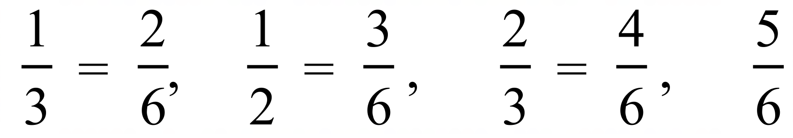 | B
 |  | C
 | 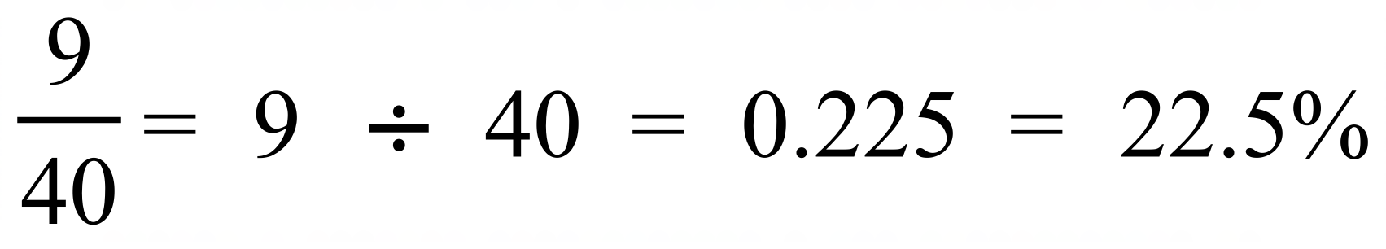 | A
 | 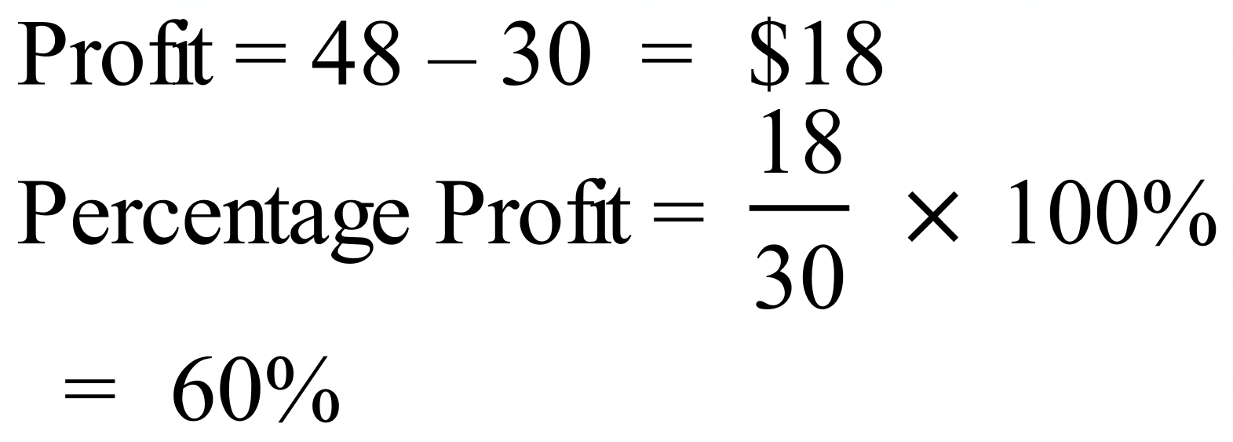 | B
 | 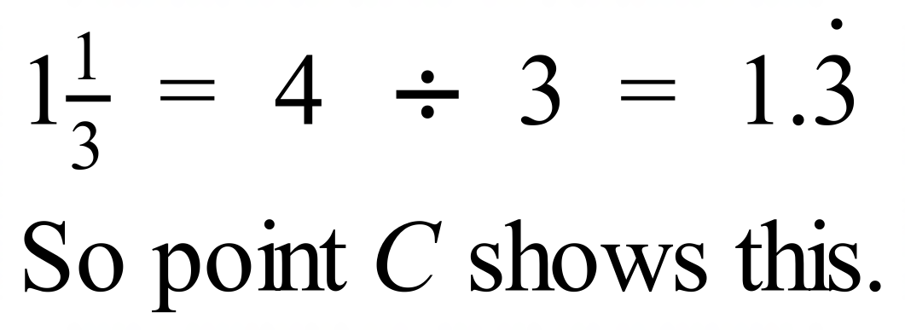 | C
 | Decrease 60 – 55 = 5 kg  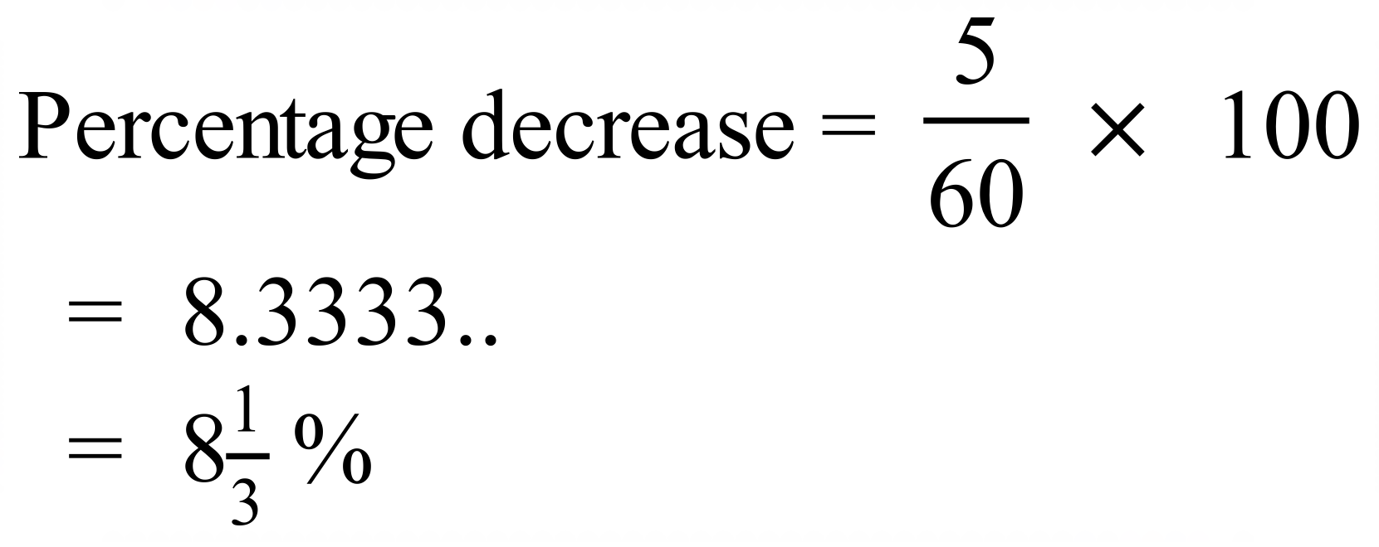 | D
 | 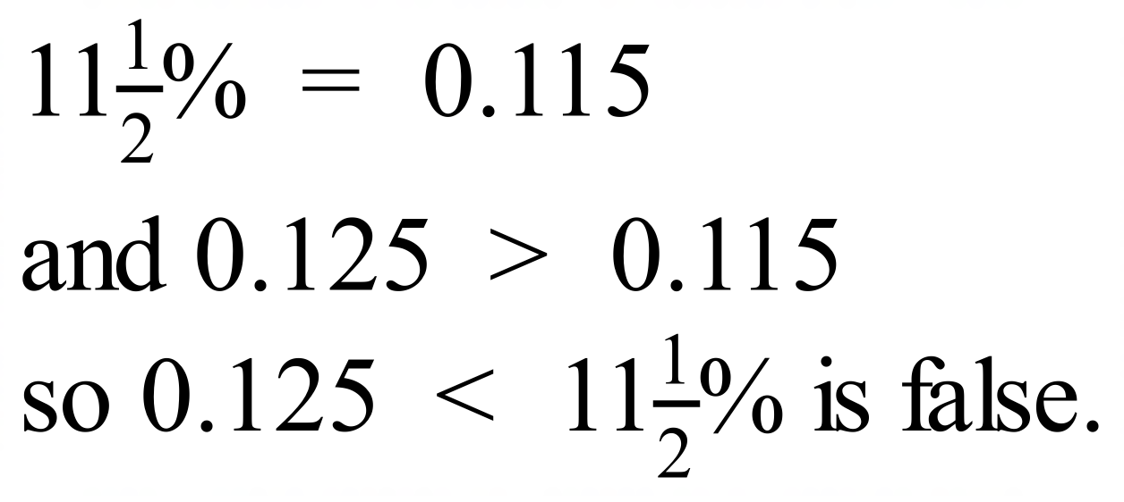 | D
 | 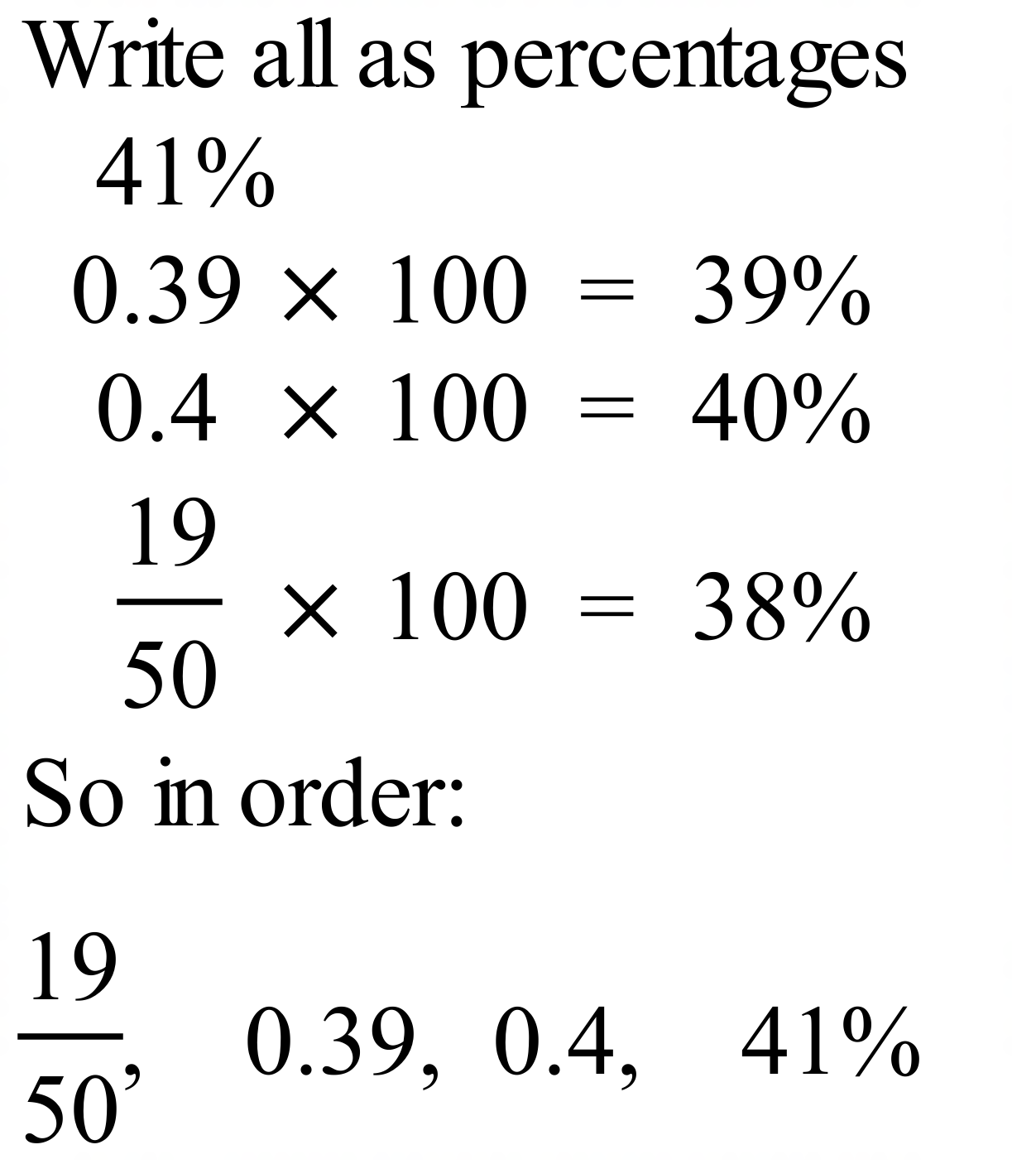 | A
 | 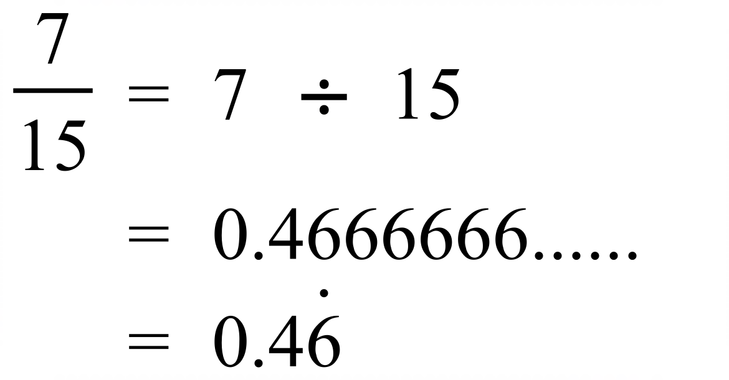 | B
 | 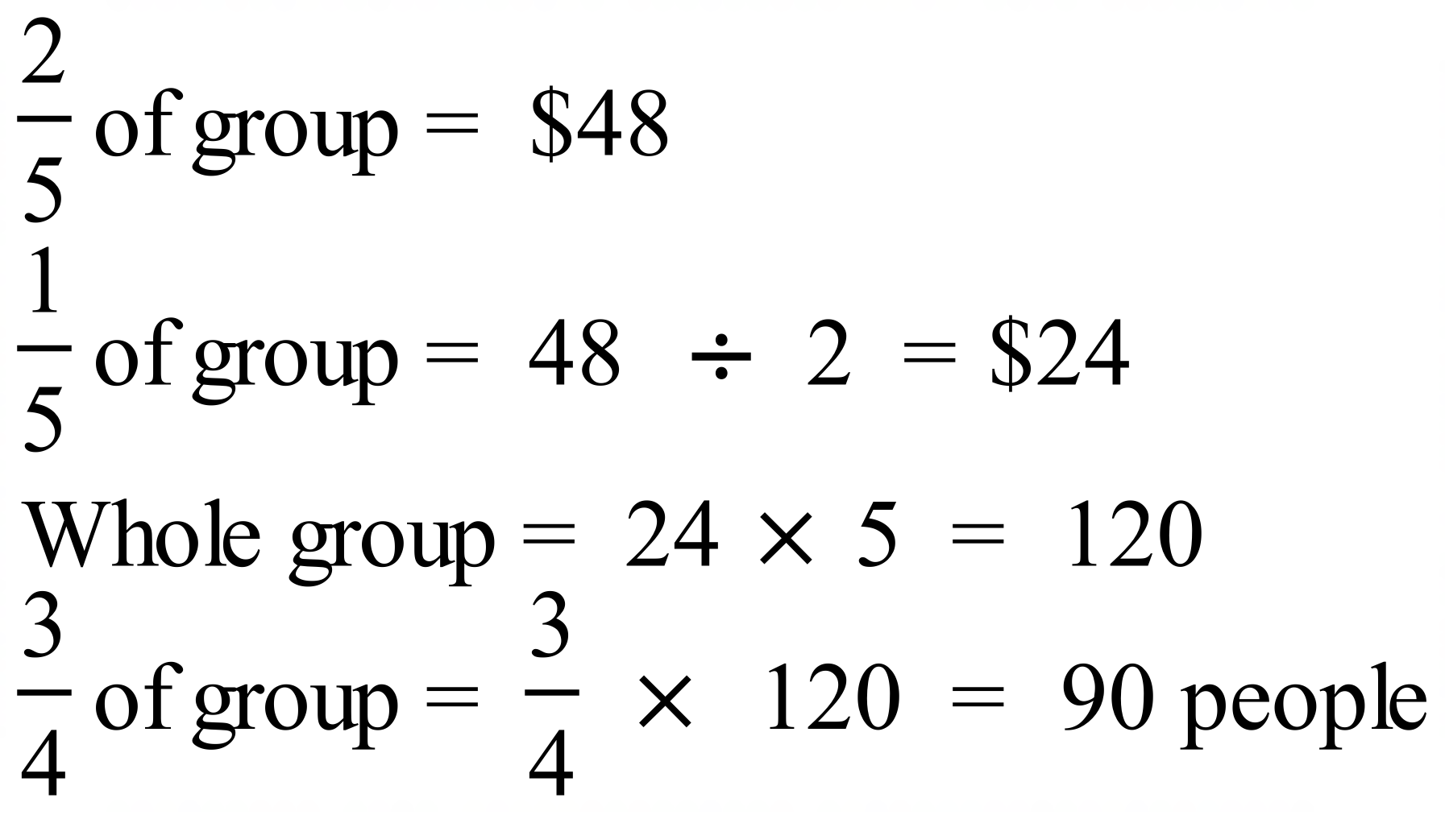 | C
 | 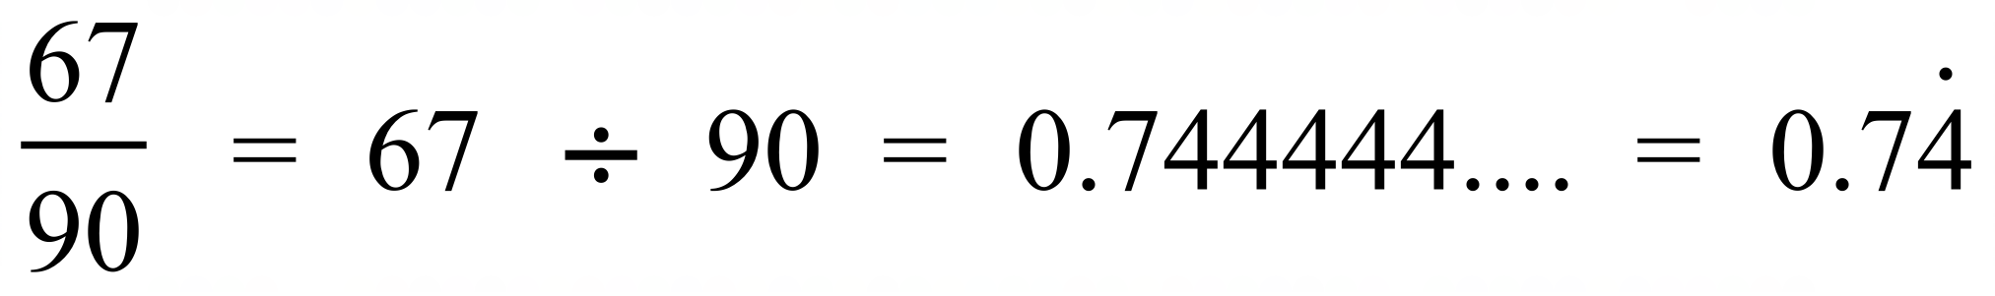 | B
 | 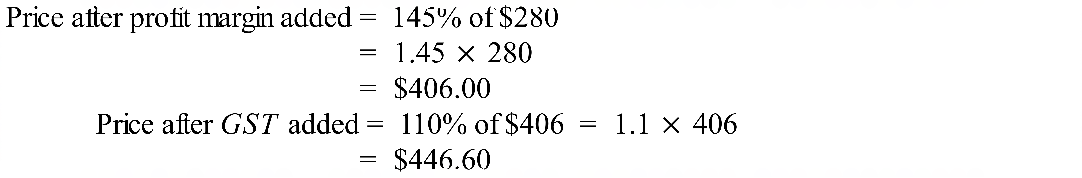 | D
 | 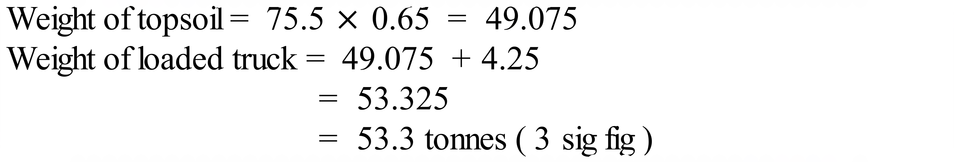 | C
 | 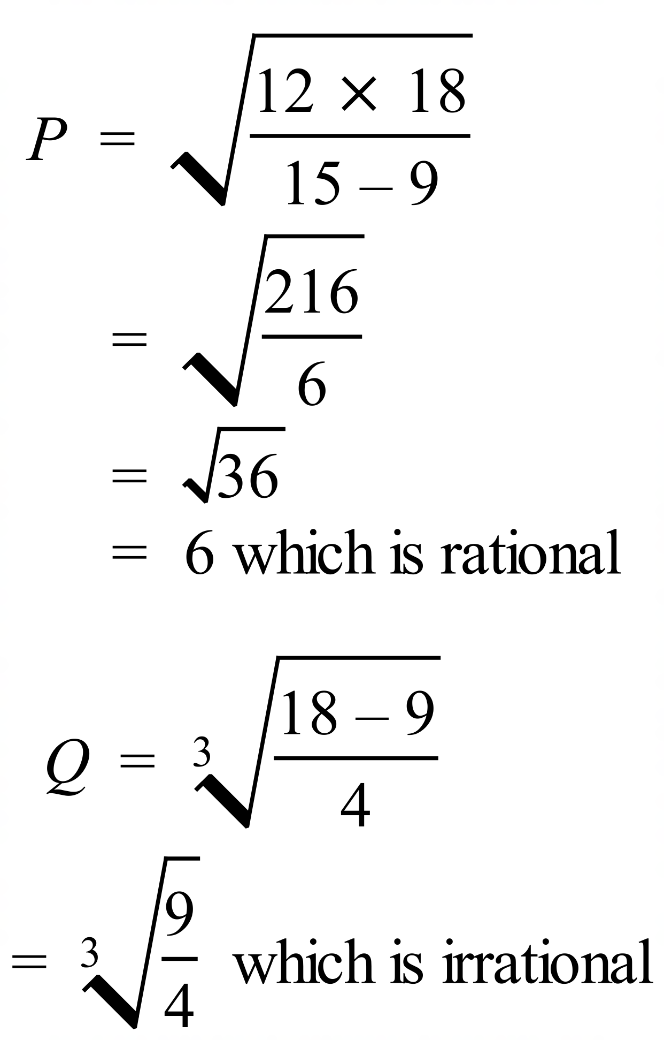 | A

School Name
Mathematics 2017
Multiple Choice Answer Sheet
Basic Number Skills
Name _____________________________________________
Completely fill the response oval representing the most correct answer.
1. A B C D
2. A B C D
3. A B C D
4. A B C D
5. A B C D
6. A B C D
7. A B C D
8. A B C D
9. A B C D
10. A B C D
11. A B C D
12. A B C D
13. A B C D
14. A B C D
15. A B C D
16. A B C D
17. A B C D
18. A B C D
19. A B C D
20. A B C D
21. A B C D
22. A B C D
23. A B C D
24. A B C D
25. A B C D

